The Renovator
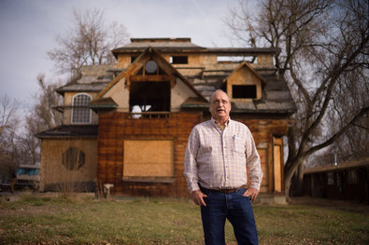

Kevin Moloney for The New York Times
Duke Marquiss had a lot of experience in real estate, but the recession meant a lack of new developments for him to work with. Today, he buys houses and renovates them for sale.
When the economy heads south, it helps to have been through the situation a few times before, says Duke Marquiss, 67, a real estate investor and broker in Fort Collins, Colo. In 1974, he bought a motel in Gillette, Wyo., during an oil and coal boom. “I made the most money of my life,” he recalls.
But the boom went bust, and in 1987, he moved to Scottsdale, Ariz., where he worked as a mortgage broker. By the time he and his wife moved to Colorado in 1989, Mr. Marquiss understood how to buy, sell, manage and rehabilitate real estate.
Today he earns his living in the real estate market niche known as A.R.V., for “after repair value.” He buys properties, restores them and sells them for a profit. Tipped off by a local friend, he bought 67 town houses in Rock Springs, Wyo., in 2005 for $75,000 apiece, on average, and sold them each for about $100,000.
Mr. Marquiss had saved carefully and lived for three years with no income during the worst years of the recession. Because of a lack of new construction, he says he couldn’t “do the development side I liked and was good at.”
“That left me back selling houses,” he adds, “so I decided I would ‘fix and flip.’ ”
Growing up on a large sheep farm taught him “ranch-hand logic,” but Mr. Marquiss acknowledges that he has had to learn his new business quickly, including how to use social media to gather advice from generous industry veterans. “LinkedIn helped a lot,” he says.
Mr. Marquiss uses only private investors to do his deals, borrowing between $15,000 and $450,000. “They’re tired of low interest rates or losing their money in the stock market,” he says.
His new line of work is not for everyone, he warns.
“You’ve got to be flexible and think very quickly,” he says. “You can’t bank on any of these deals ever closing.”
Before he found his new field, his wife suggested at one point that he find a full-time job working for someone else. He sent out 200 résumés, but received only one call. Sharply reducing their costs of living helped Mr. Marquiss and his wife, Ginger, weather the transition to their new life. They sold their 3,000-square-foot mountain home and now live in a condominium a third of the size in Fort Collins. He also saves $600 to $700 a month on gasoline by not commuting 45 minutes each way into town.
“It takes a conscious decision to reduce your overhead,” he says. “I see so many people in denial about where they really are financially.”
Jan 12, 2013 By Caitlin Kelly New York Times

